**实验1.2**

实验1.2相关材料位于：<ftp://192.168.40.100/>下的“**--- 梁其洋**”目录下（可以通过搜索名字找到）

作业提交到：[ftp://192.168.40.14/梁其洋/网络编程**班/实验1.2](ftp://192.168.40.14/梁其洋/网络编程**班/实验1.2)

要求：

1. 保存运行成功的截图到文档末尾；

2. 提交时**将本文档重新命名**，文档命名规则：学号+姓名+实验1，例如，**517300614400 张三 实验1.2.docx （一定要学号在前姓名在后，方便自动排序！）**

3. 你们没有FTP文件的删除权限，**如果需要提交新版本，在姓名后加序号后提交即可，例如，517300614400张三（1）实验1.2.docx**

**实验目的：**

掌握DNS域名解析和IP地址转换的基本用法

**实验步骤：**

步骤一：新建一个名为Example1的WPF工程，进入MainWindow.xaml文件，在窗体上添加5个控件：泊靠式面板（DockPanel）、标签（Label）、按钮（Button）、滚动条（ScrollViewer）、静态文本（TextBlock）。

<Window x:Class="Example1.MainWindow"

xmlns="http://schemas.microsoft.com/winfx/2006/xaml/presentation"

xmlns:x="http://schemas.microsoft.com/winfx/2006/xaml"

xmlns:d="http://schemas.microsoft.com/expression/blend/2008"

xmlns:mc="http://schemas.openxmlformats.org/markup-compatibility/2006"

mc:Ignorable="d"

Title="张三_MainWindow" Height="350" Width="525"> 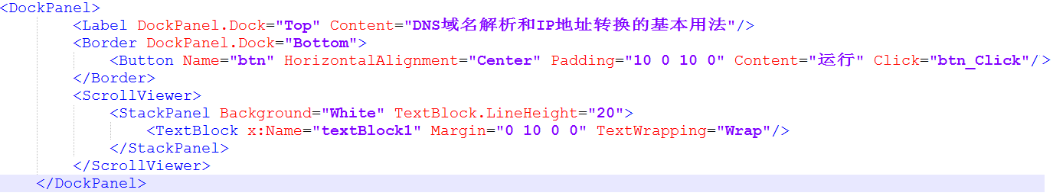

</Window>

步骤二：切换到MainWindow.xaml.cs中添加

using System.Net;

using System.Net.Sockets;

**实现btn_Click方法：**

private void btn_Click(object sender, RoutedEventArgs e)

{

StringBuilder sb = new StringBuilder();

sb.AppendLine("获取www.cctv.com的所有IP地址：");

try

{

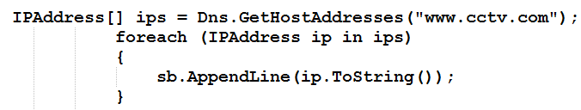

}

catch (Exception ex)

{

MessageBox.Show(ex.Message, "获取失败");

}

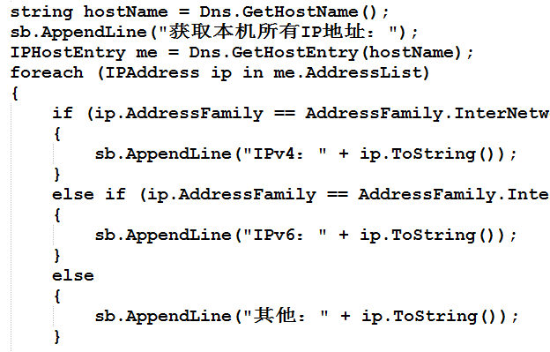

}

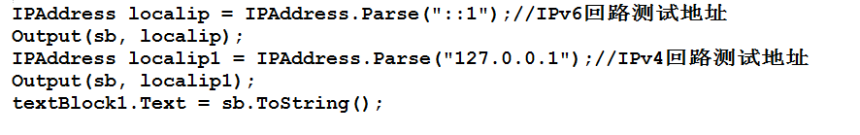

}

步骤三：接着btn_Click(……)函数下面添加辅助函数Output(……)

private static void Output(StringBuilder sb, IPAddress localip)

{

IPEndPoint iep = new IPEndPoint(localip, 80);

if (localip.AddressFamily == AddressFamily.InterNetworkV6)

{

sb.Append("IPv6端点： " + iep.ToString());

}

else

{

sb.Append("IPv4端点： " + iep.ToString());

}

sb.Append("，端口 " + iep.Port);

sb.Append("，地址 " + iep.Address);

sb.AppendLine("，地址族 " + iep.AddressFamily);

}

运行截图：

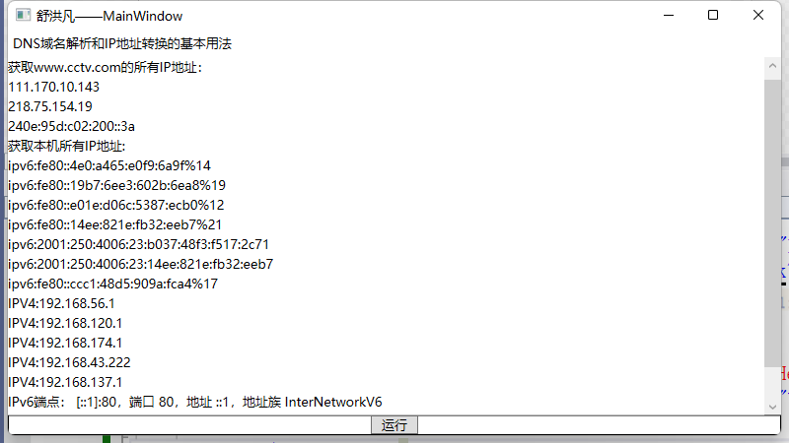

<Window x:Class="sy1_2.MainWindow"

xmlns="http://schemas.microsoft.com/winfx/2006/xaml/presentation"

xmlns:x="http://schemas.microsoft.com/winfx/2006/xaml"

xmlns:d="http://schemas.microsoft.com/expression/blend/2008"

xmlns:mc="http://schemas.openxmlformats.org/markup-compatibility/2006"

xmlns:local="clr-namespace:sy1_2"

mc:Ignorable="d"

Title="舒洪凡——MainWindow" Height="450" Width="800">

<DockPanel LastChildFill="False">

<Label DockPanel.Dock="Top" x:Name="label" Content="DNS域名解析和IP地址转换的基本用法"/>

<Border DockPanel.Dock="Bottom" BorderBrush="Black" BorderThickness="1">

<Button HorizontalAlignment="Center" Padding="10 0 10 0" x:Name="button" Content="运行" Width="Auto" Click="button_Click"/>

</Border>

<ScrollViewer>

<StackPanel Background="White" TextBlock.LineHeight="20" Width="773">

<TextBlock x:Name="textBlock" TextWrapping="Wrap" Margin="0 10 0 0" Text="TextBlock" />

</StackPanel>

</ScrollViewer>

</DockPanel>

</Window>

using System;

using System.Collections.Generic;

using System.Linq;

using System.Net;

using System.Net.Sockets;

using System.Text;

using System.Threading.Tasks;

using System.Windows;

using System.Windows.Controls;

using System.Windows.Data;

using System.Windows.Documents;

using System.Windows.Input;

using System.Windows.Media;

using System.Windows.Media.Imaging;

using System.Windows.Navigation;

using System.Windows.Shapes;

namespace sy1_2

{

/// <summary>

/// MainWindow.xaml 的交互逻辑

/// </summary>

public partial class MainWindow : Window

{

public MainWindow()

{

InitializeComponent();

}

private void button_Click(object sender, RoutedEventArgs e)

{

StringBuilder sb = new StringBuilder();

sb.AppendLine("获取www.cctv.com的所有IP地址：");

try

{

IPAddress[] ipAddresses = Dns.GetHostAddresses("www.cctv.com");

foreach (IPAddress ip in ipAddresses)

{

sb.AppendLine(ip.ToString());

}

}

catch (Exception exception)

{

MessageBox.Show(exception.Message, "获取失败");

}

string hostName = Dns.GetHostName();

sb.AppendLine("获取本机所有IP地址:");

IPHostEntry me = Dns.GetHostEntry(hostName);

foreach (IPAddress ip in me.AddressList)

{

if (ip.AddressFamily==AddressFamily.InterNetwork)

{

sb.AppendLine("IPV4:"+ip.ToString());

}

else if (ip.AddressFamily == AddressFamily.InterNetworkV6)

{

sb.AppendLine("ipv6:" + ip.ToString());

}

else

{

sb.AppendLine("其他：" + ip.ToString());

}

}

IPAddress localip = IPAddress.Parse("::1");

Output(sb, localip);

IPAddress localip1 = IPAddress.Parse("127.0.0.1");

Output(sb, localip1);

textBlock.Text = sb.ToString();

}

private static void Output(StringBuilder sb, IPAddress localip)

{

IPEndPoint iep = new IPEndPoint(localip, 80);

if (localip.AddressFamily == AddressFamily.InterNetworkV6)

{

sb.Append("IPv6端点： " + iep.ToString());

}

else

{

sb.Append("IPv4端点： " + iep.ToString());

}

sb.Append("，端口 " + iep.Port);

sb.Append("，地址 " + iep.Address);

sb.AppendLine("，地址族 " + iep.AddressFamily);

}

}

}